Quiz 4: Circular Motion

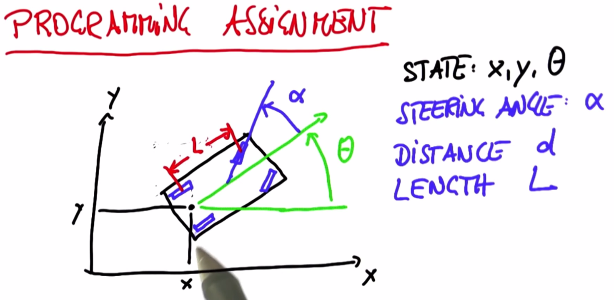

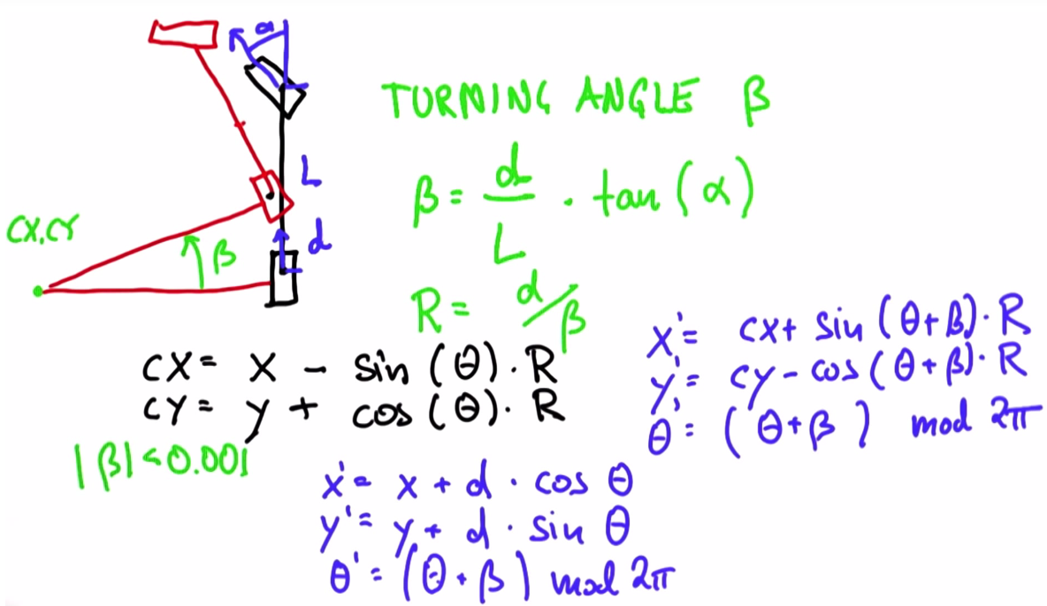

This model is just for programming purpose. NOT be proofed by derivation.

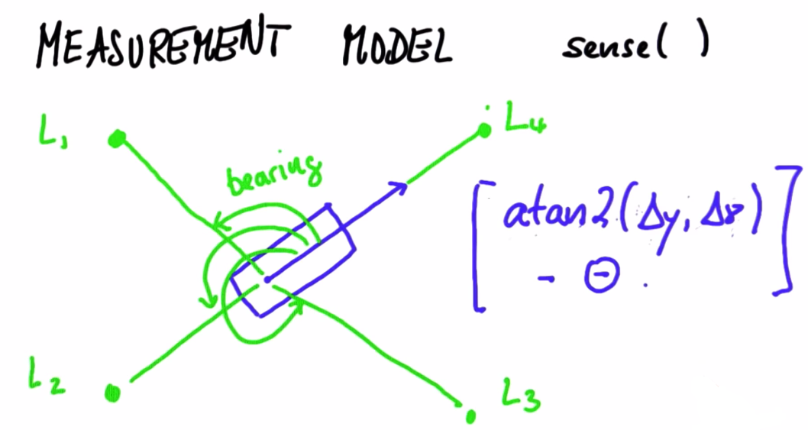

Lesson 10: Problem Set 3 Help

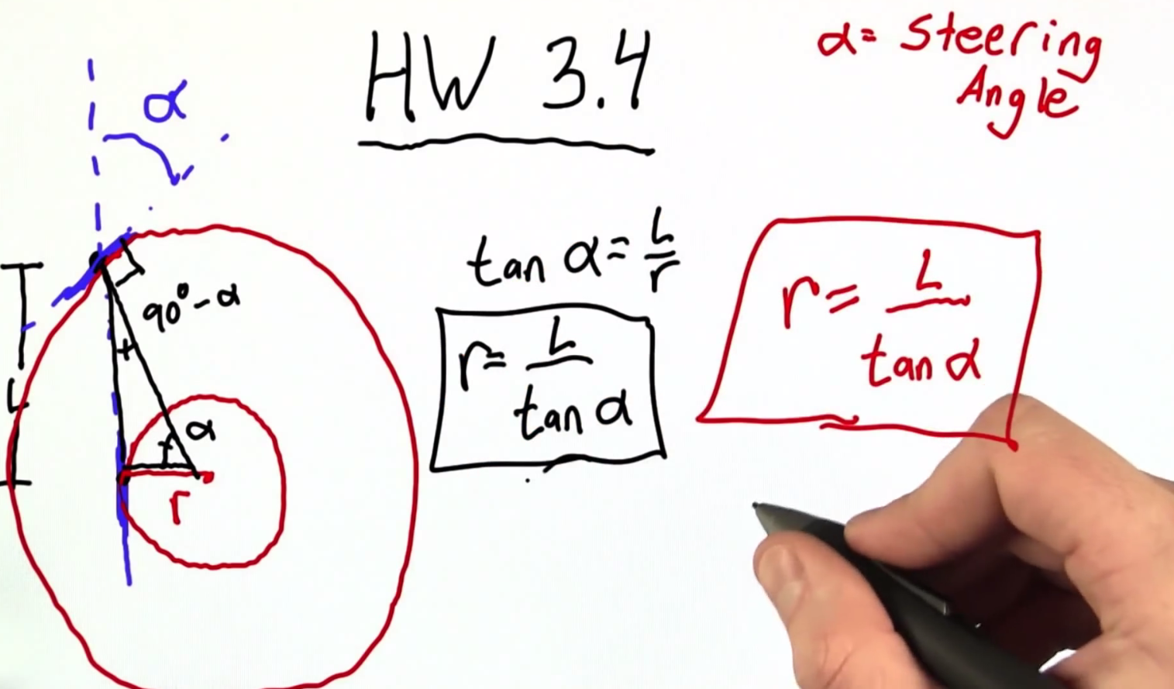

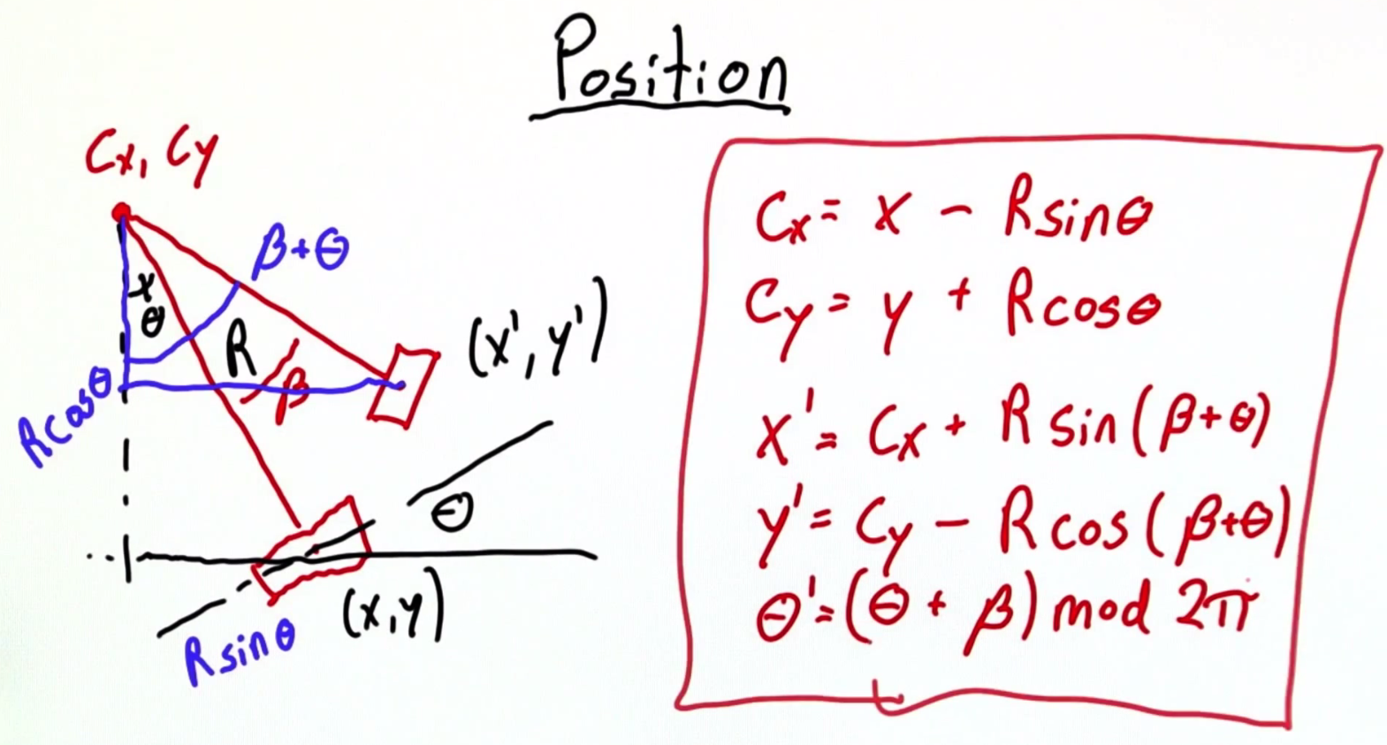

These derivations are NOT the problem, the tricky ones are:

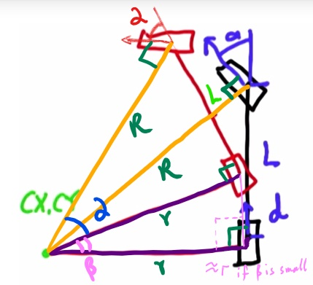Under the assumption that is small enough, and .